weekly memorandum

|  |  |
| --- | --- |
| to: | James Pettit |
| from: | Tommy arrington |
| subject: | My progress on designing the launch relay system |
| date: | September 27, 2015 |
|  |  |

**LAST WEEK**

Last week I focused on creating a high level, black box system diagram for the launch relay system by determining all of the components that will be required to get the desired functionality and improve the reliability issues faced last year (attached below). The sensor inputs and relay outputs only show examples, because the Propulsion team has not yet finalized the data they will require during launch or the number of relays needed for SRT-3’s engine control. In selecting the launch relay system controller, I considered the cost, performance, Input/Output capacity, and power consumption of the [Arduino Uno R3](https://www.arduino.cc/en/Main/ArduinoBoardUno), [Raspberry Pi 2 B](https://www.raspberrypi.org/products/raspberry-pi-2-model-b/), [NI’s myRIO](http://www.ni.com/myrio/buy/), and the Relay Pros [8-Channel ProXR XSC Relay](http://www.relaypros.com/Relay/Device/ZADR810PROXR_XSC#.Vghck3uUQn8). I chose the Arduino because of its reliability, ease of integration with the Xbee-PRO 900HP, ability to be powered by a battery, robust I/O system, and adequate but not oversized processing power. I also found 2 shields that will increase the performance to give easy I/O access with the sensors and relays ([ProtoScrewShield](https://www.sparkfun.com/products/9729)) and give a direct connection to the Xbee ([Xbee Shield](https://www.sparkfun.com/products/12847)). The combination of 9V batteries and one 12V car battery gives 2 reliable and independent systems that will prevent the controller from failing if a high power component fails. The set up will also allow the car battery to be placed immediately next to the launch box because of the secondary arming relay that will be activated once people are a safe distance away.

**THIS WEEK**

This week I will work on determining a general system of transistors, op-amps, and other components that will fit in each “black box” on the diagram and give functionality to the types of sensors we will likely use.

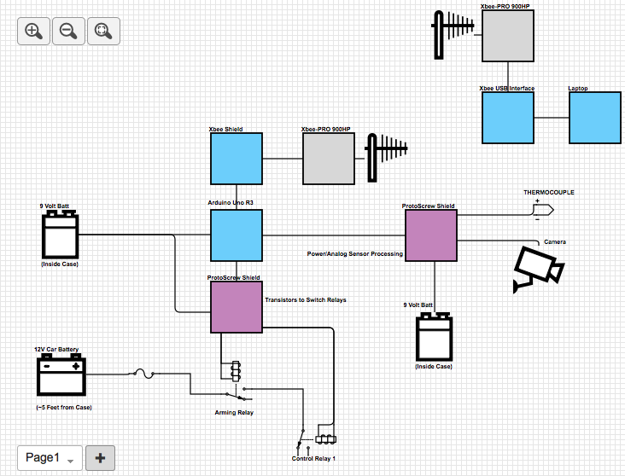**NOTES**: -Only one relay for controlling actuators (Control Relay 1) is shown. It is not known at this time how many relay channels must be supported, and further ones will have the common pin connected through the NO pin of the arming relay.

Black box Hardware Overview Diagram – Launch Relay System

-The thermocouple and camera are only examples of sensors that may be used. The driving and amplification circuits (in the “Power/Analog Sensor Processing” block) are dependent on the actual sensors needed, and will be decided in the future.